Vehicle

|  |  |  |  |  |  |
| --- | --- | --- | --- | --- | --- |
|  | Vid |  | Vname | Price | desc |
|  |
| 1 | |  | Activa | 80000 | Easy to use |
| 2 | |  | Santro | 8,00000 | comfort |
| 3 | |  | Motor bike | 100000 | mileage |

customer

|  |  |  |  |  |
| --- | --- | --- | --- | --- |
|  | Custid |  | Cname | address |
| 1 | |  | Nilima | Pimpari |
| 2 | |  | Ganesh | Pune |
| 3 | |  | Pankaj | Mumbai |

salesman

|  |  |  |  |  |
| --- | --- | --- | --- | --- |
|  | Sid |  | Sname | adress |
| 10 | |  | Rajesh | mumbai |
| 11 | |  | Seema | Pune |
| 13 | |  | Rakhi | pune |

cust-vehicle (customer is buying Many vehicle and 1 vehicle can be bought by many customers)

|  |  |  |  |  |  |  |  |
| --- | --- | --- | --- | --- | --- | --- | --- |
|  | Custid |  |  | Vid |  | Sid | Buy_price |
| 1 | |  | 1 | |  | 10 | 75000 |
| 1 | |  | 2 | |  | 10 | 7,90,000 |
| 2 | |  | 3 | |  | 11 | 80000 |
| 3 | |  | 3 | |  | 11 | 75000 |
| 3 | |  | 2 | |  | 10 | 8,00000 |

1. create all given tables.

Create table vehicle (

Vid int primary key,

Vname varchar(30) not null,

Price double(10,2) check (price > 0),

Description text

);

Insert into vehicle values (1 ,”Activa”,80000 ,”Easy to use”);

Insert into vehicle values (2,”Santro”,800000,”comfort”);

Insert into vehicle values (3,”Motor bike”, 100000,“mileage”);

Create table customer (

Cid int primary key,

Cname varchar(30) not null,

Address text

);

Insert into customer values (1,”Nilima”,”Pimpari”);

Insert into customer values (2,”Ganesh”,”Pune”);

Insert into customer values (3,”Pankaj”,”Mumbai”);

Create table salesman(

Sid int primary key,

Sname varchar(30) not null,

Address text

);

Insert into salesman values (10,”Rajesh”,”Mumbai”);

Insert into salesman values (11,”Seema”,”Pune”);

Insert into salesman values (13,”Rakhi”,”Pune”);

Create table cust_vehicle(

Cid int,

Vid int,

Sid int,

Buy_price double(10,2) not null,

Constraint pk primary key (cid,vid),

Constraint fk_cid foreign key (cid) references customer(cid) on delete cascade on update cascade,

Constraint fk_vid foreign key (vid) references vehicle(vid) on delete cascade,

Constraint fk_sid foreign key (sid) references salesman(sid) on delete set null on update cascade);

Insert into cust_vehicle values (1,1,10,75000);

Insert into cust_vehicle values (1,2,10,790000);

Insert into cust_vehicle values (2,3,11,80000);

Insert into cust_vehicle values (3,3,11,75000);

Insert into cust_vehicle values (3,2,10,800000);

1. create index on vehicle table based on price
2. find all customer name,vehicle name, salesman name, discount earn by all customer

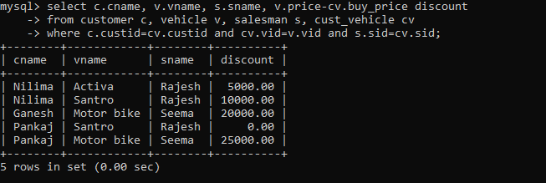

1. find all customer name,vehicle name,salesman name for all salesman who stays in pune

select c.cname,v.vname,s.sname

from salesman s, customer c, vehicle v,cust_vehicle cv

where s.sid =cv.sid and v.vid =cv.vid and cv.sid in (select sid from salesman s where address = “pune”);

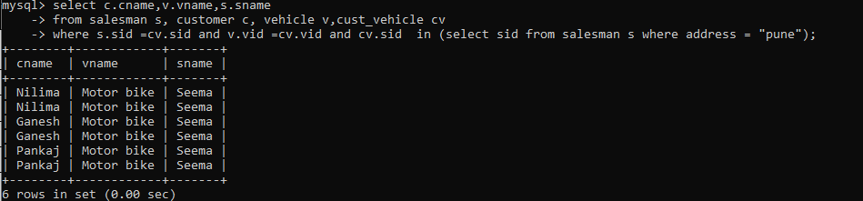

1. find how many customers bought motor bike

select count(*)

from cust_vehicle

where vid = (select vid from vehicle where vname =”motor bike”);

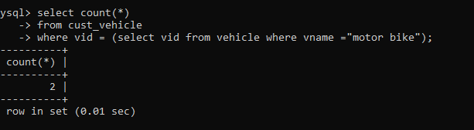

1. create a view find_discount which displays output -------to create view

create view find_discount

as

select cname,vname,price,buying_price,price-buying_price “discount” from customer c inner join cust_vehicle cv on c.custid=cv.cid inner join vehicle v on v.vid=cv.vid

--------to display discount select * from find_discount;



Create view find_discount

As

select c.cname,v.vname,v.price ,cv.buy_price,v.price - cv.buy_price “discount” from customer c inner join cust_vehicle cv on c.custid=cv.custid inner join vehicle v on v.vid=cv.vid;

select * from find_discount;

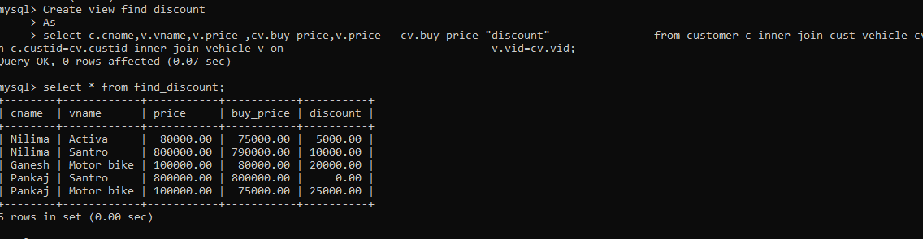

1. find all customer name, vehicle name, salesman name, discount earn by all customer.

select c.cname,v.vname,sname, v.price - cv.buy_price “discount”

from salesman s, customer c, vehicle v,cust_vehicle cv

where s.sid =cv.sid and v.vid =cv.vid and cv.custid =c.custid and v.price –cv.buy_price != 0 ;

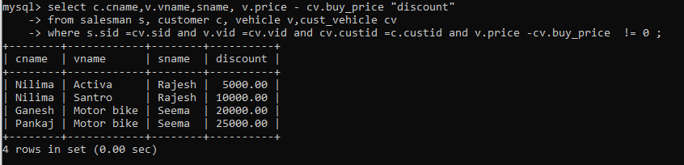

1. create view my_hr to display empno,ename,job,comm for all employees who earn commission.

Create view my_hr

As

Select empno,ename ,job,comm

From emp

Where comm is not null;

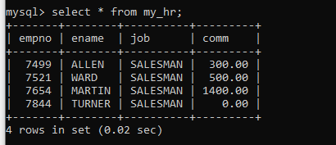

1. create view mgr30 to display all employees from department 30.

Create view mgr30

As

Select *

From emp

Where deptno=30;

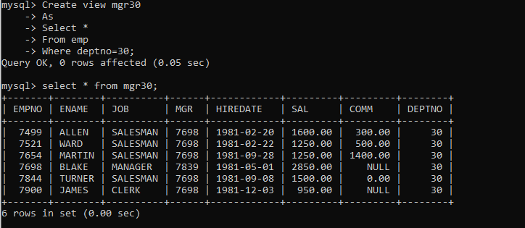

1. insert 3 employees in view mgr30 check whether insertion is possible

insert into mgr30 values (7822,”saikat”,”manager”,7912,curdate(),4500,1800,10);

insert into mgr30 values (7823,”kunal”,”manager”,7822,curdate(),4000,2300,20);

insert into mgr30 values (7824,”adarsh”,”analyst”,7823,curdate(),3800,800,10);

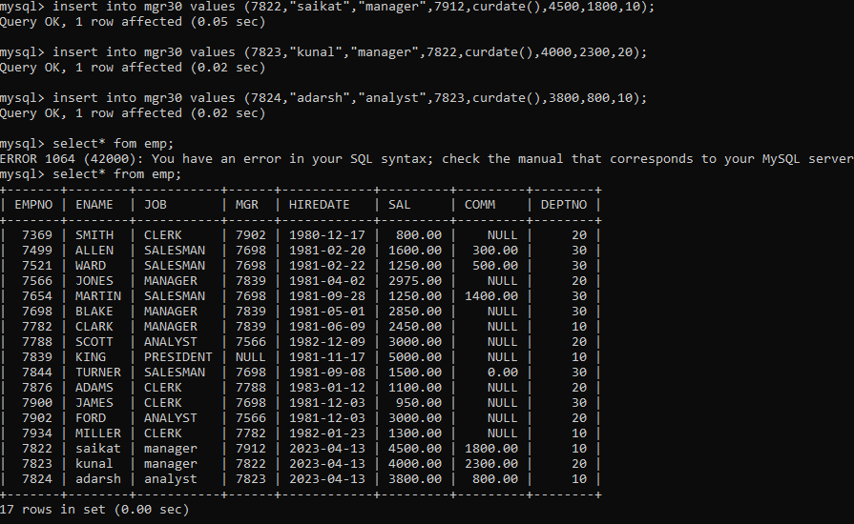

1. insert 3 records in dept and display all records from dept

insert into dept values (40,”purchase”,”pune”);

insert into dept values (50,”QA”,”mumbai”);

insert into dept values (60,”maintanence”,”nashik”);

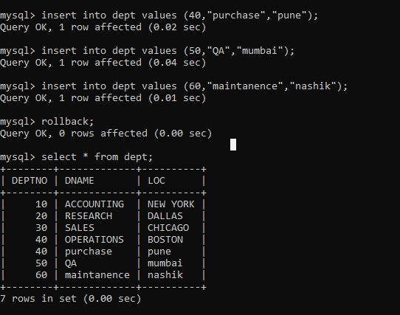

1. use rollback command check what happens.
2. do the following insert row in emp with empno 100 insert row in emp with empno 101 insert row in emp with empno 102 add savepoint A

insert row in emp with empno 103 insert row in emp with empno 104 insert row in emp with empno 105 add savepoint B delete emp with empno 100 delete emp with emp no 104 rollback upto svaepoint B check what all records will appear in employee table rollback upto A

check what all records will appear in employee table commit all changes

check what all records will appear in employee table check whether you can roll back the contents.

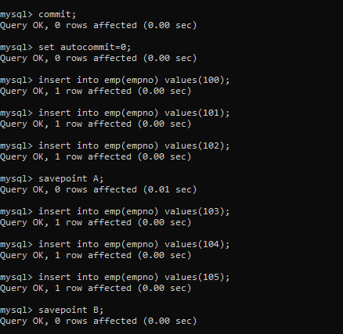

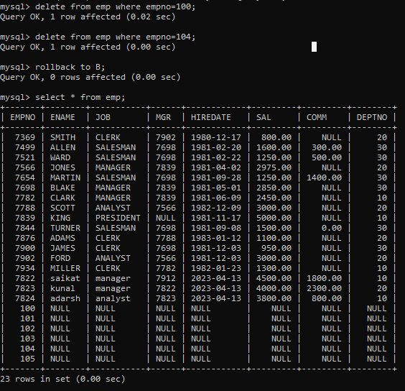

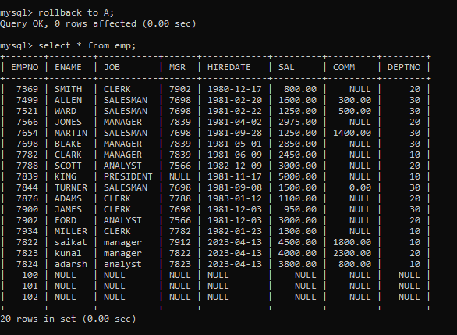

1. create a procedure getMin(deptno,minsal) to find minimum salary of given table.

Delimiter //

Create procedure getMin(inout dpno int , out min_sal double(9,2))

Begin

Select min(sal) into min_sal

From emp

Where deptno = dpno;

End //

Delimiter ;

